Revela — Case Study
Nov 4, 2026 · @Nazor

At a glance
Revela is a web platform that lets African event organisers plan, sell tickets for, promote and follow up on an event in one place, instead of juggling five tools.
My role | Product designer, supporting role: most of the screens, not the overall direction
Platform | Web app for organisers, with a public landing page and event discovery for guests
Scope | MVP: landing page, sign-up, event creation, event dashboard, ticketing, guest management, post-event surveys and certificates, reports
Timeline | June 2025

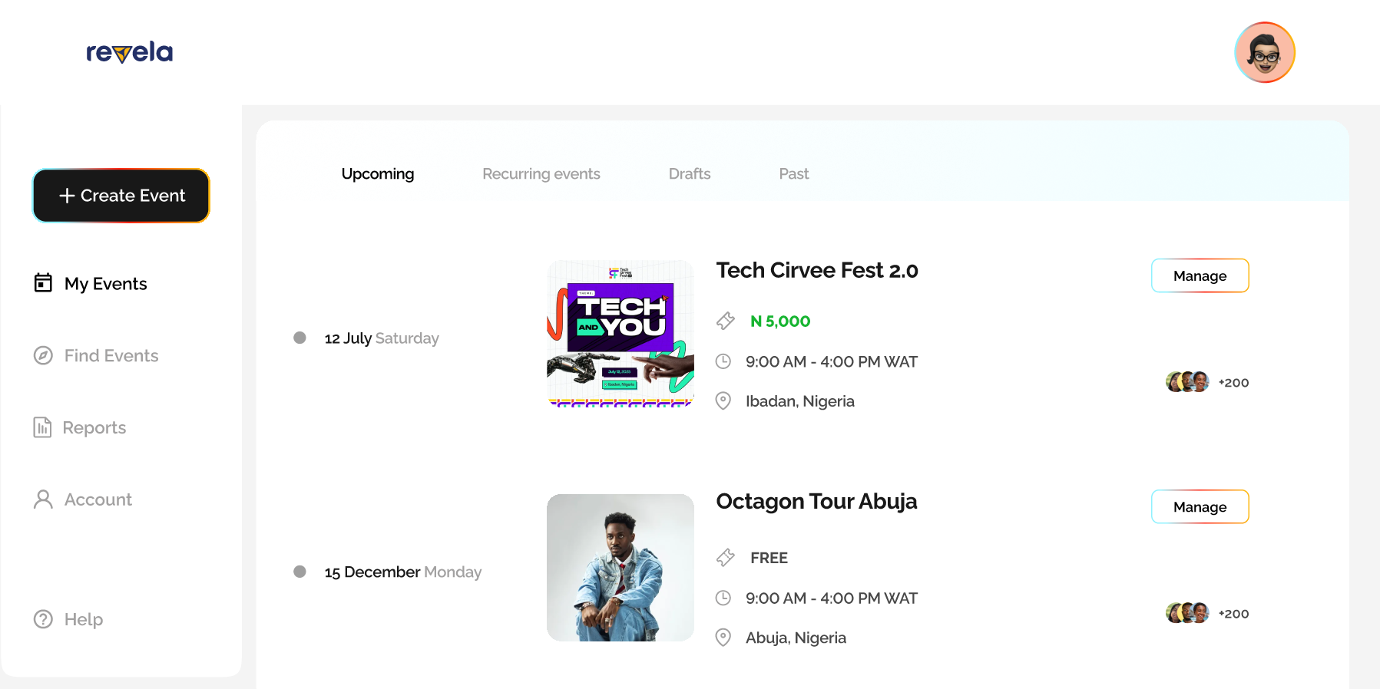

The problem
An organiser in Nigeria typically runs one event across several tools: Eventbrite for tickets, Canva for the flyer, WhatsApp for reminders, Google Forms for registration and Excel for the guest list. Every hand-off is a chance to lose a guest or double-book a ticket.
The tools built to replace that stack miss in two directions:
- Too heavy. Zoho Backstage and Eventbrite are built for large teams, with cluttered dashboards, high fees and a steep learning curve.
- Too light. Tix Africa and Luma are simple, but offer little automation, branding control or follow-up after the event.
Neither group handles local needs well: payment methods people trust, and WhatsApp as the main way to reach an audience.
The design question became: how do we give a non-technical organiser the whole event lifecycle in one calm interface, without enterprise bloat?

What the research showed
A review of four competitors pointed to a gap between over-built and under-built tools, and to follow-up after the event as the least served need.
Platform | Strength | Weakness | Opening for Revela
Eventbrite | Trusted, discoverable, many integrations | Cluttered organiser dashboard, high fees, limited branding | Cleaner dashboard, simpler setup
Zoho Backstage | Enterprise features, hybrid events | Steep learning curve, too heavy for small events | Simple by default, advanced when needed
Luma | Sleek, community-friendly | Limited depth for larger events | Features that scale with the organiser
Tix Africa | Built for Africa, local payments, mobile-first | Basic analytics, few integrations, weak branding | Analytics, branding and automation
Three insights shaped the product:
- Discovery and retention are split. Platforms that are good at finding events are weak at following up, and the reverse. Revela needed both.
- Post-event is unserved. Certificates, shareable images and feedback loops were largely missing.
- Local behaviour is not a plug-in. WhatsApp and local payment methods had to be part of the core design, not an add-on.
The research defined four audiences: content creators and coaches, corporate event managers, independent planners, and community organisers. Three working personas (a creator in Lagos, a corporate planner in Abuja and a tech community lead in Ibadan) kept the design grounded in real contexts.

My role
I worked on Revela as a product designer at Cosmos Design Space, in a supporting role. I designed most of the screens, working within a design direction set by the studio rather than by me.
That covered the landing page, sign-up and verification flows, event creation, the event dashboard and its tabs, ticketing, guest tools, post-event surveys and certificates, reports, and the email and ticket templates. The brand, the product scope and the overall visual direction were not my decisions, so the decisions below are about how I resolved the flows and interfaces inside that frame.

Key design decisions

1. Make the event the workspace
Organisers were running one event across several tools, so each event became a single workspace with six tabs: Overview, Guests, Tickets, Messages, Post Event and More Options. Everything needed to run the event sits one tab away, and the Overview pulls the essentials (price, date, location, recent registrations, tickets, host) into one scannable page.
[image: Screen202026-11-04%20084725_92bf6540.gif]
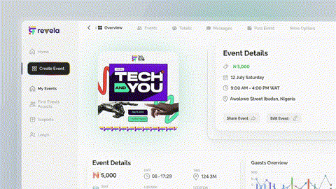

2. Give organisers branding without a second tool
Event themes, guest profile (display picture) templates and certificate templates let organisers produce branded material inside Revela rather than designing it in Canva, which removes another tool from the stack.
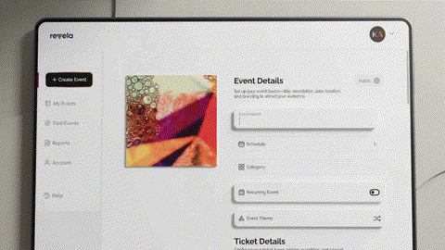

3. Keep guest registration short, and open the door to discovery
Guests register with a name, phone number and email, plus an optional message. A public Find Events page with category chips and a country filter lets guests browse events, and a Reports page gives organisers attendance, page views and traffic by city, covering both discovery and retention.

Outcome and reflection
The MVP design covers the full organiser journey: sign up, create an event, sell tickets, manage guests, follow up and review reports, plus the guest-facing landing, discovery, registration and email touchpoints.
- Outcome: We delivered the MVP 1 features, including mobile responsiveness.
- What I learned: This project was a refreshing change from the other project I was working on at the time, and I enjoyed working with everyone on the team, from my co-designer to the PM, the developers and the product owner. Everyone did what needed to be done, which made the entire process seamless.

